**WITH NOISE AND WITH FILTER FUZZY**

**Image set:**

|  |
| --- |
| **Image 1:-0.1 % Noise** |

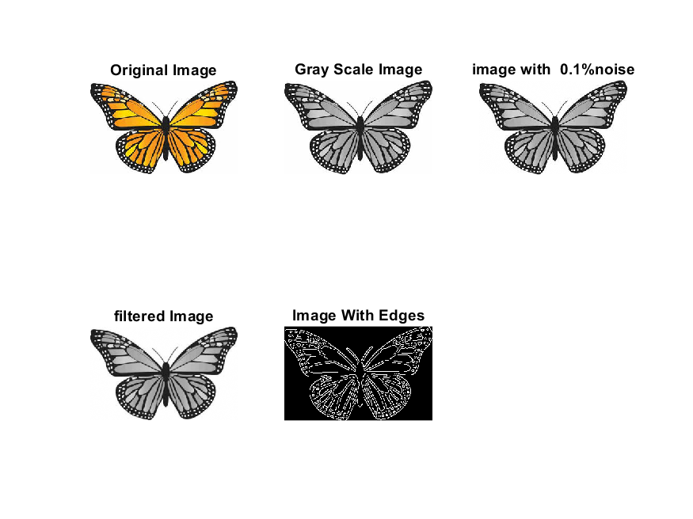

**Image 2:-10 % Noise**

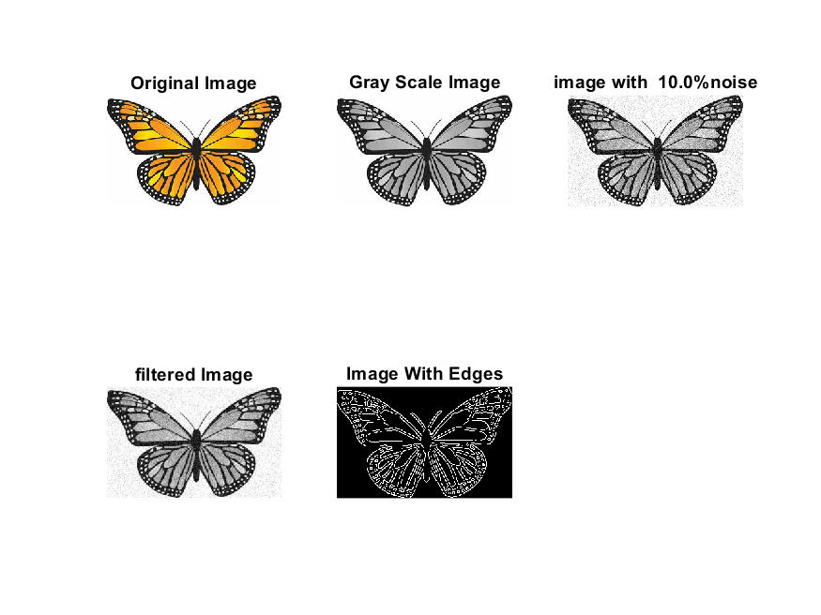

**Image 3:-20 % Noise**

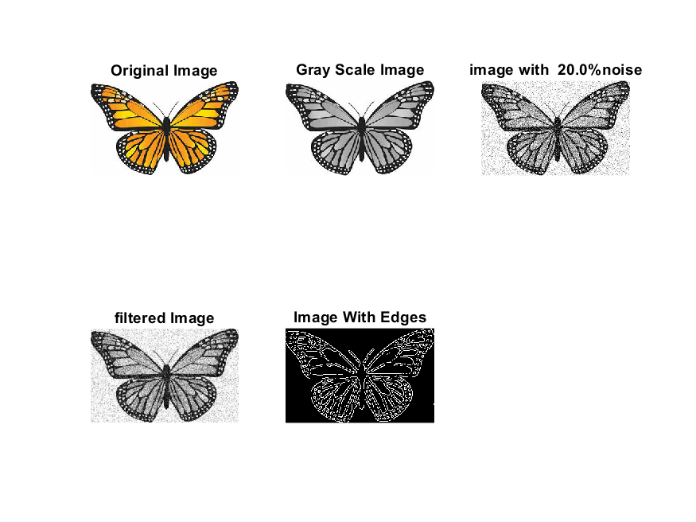

**Image 4:-30 % Noise**

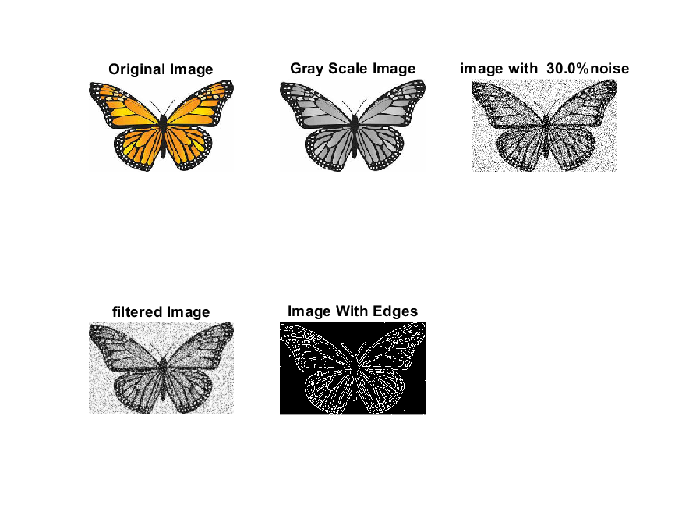

|  |
| --- |
| **Image 5:-40 % Noise** |

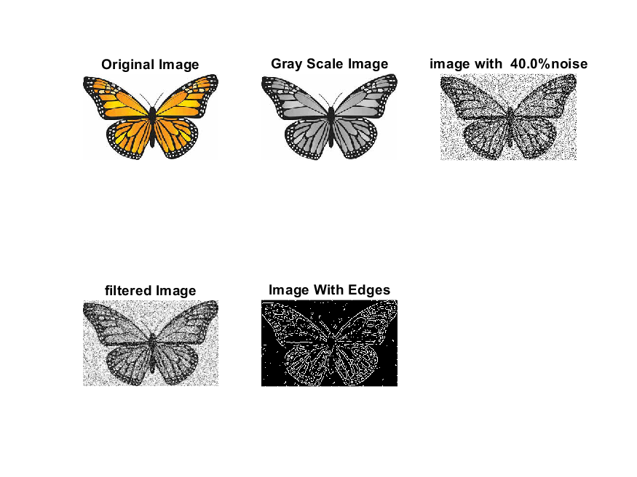

**Image 6:-50 % Noise**

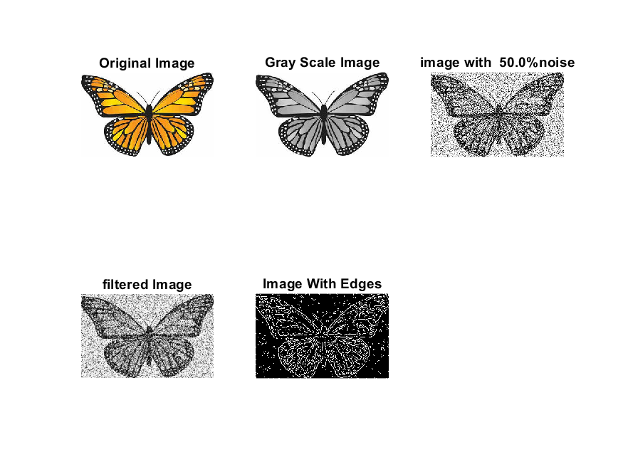

**Image 7:-60 % Noise**

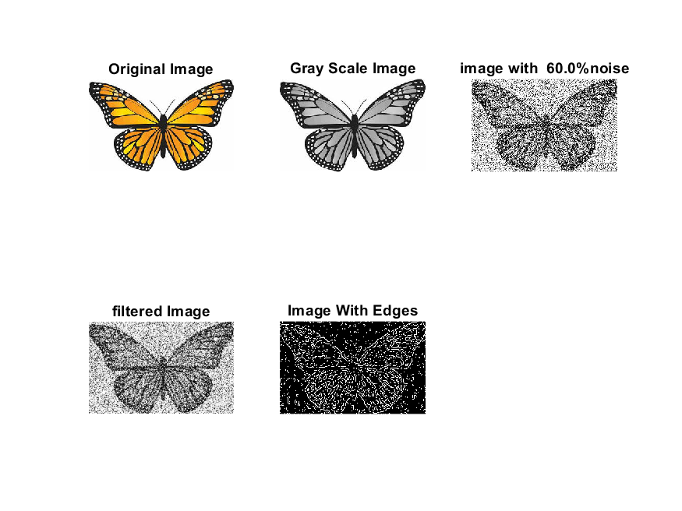

**Image 8:-70 % Noise**

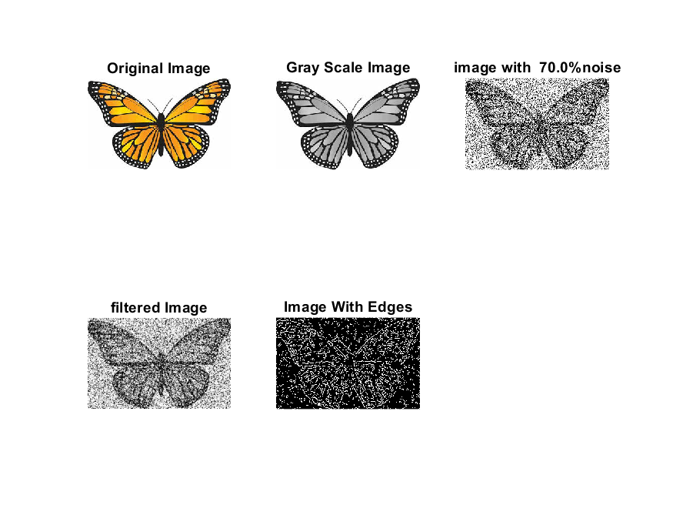

**Image 9:-80 % Noise**

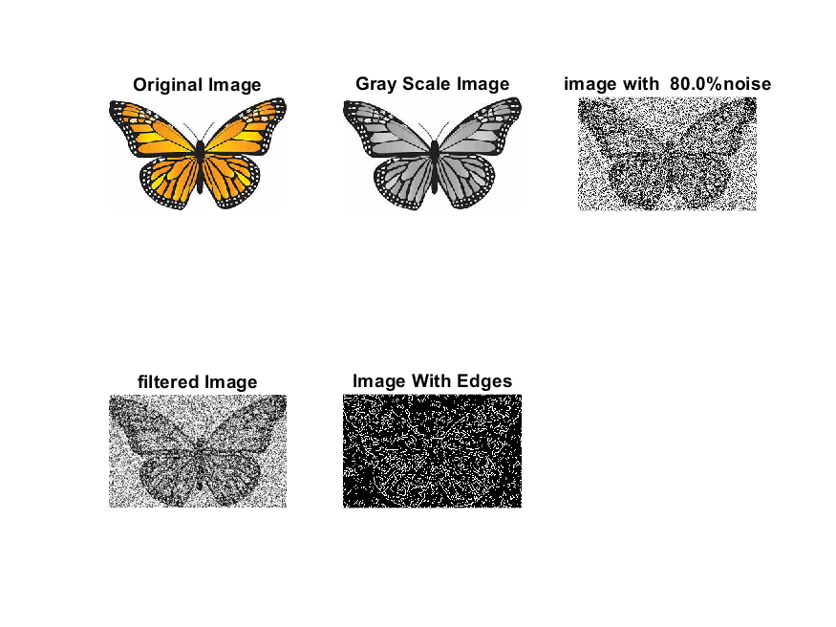

**DATA FILES**

**Image 1:-Noise0.1**

Original image ideal values:

IM1 image entropy:5.646126e-01

IM1 image mean:0.132632

Ground truth image entropy:0.968631

Ground truth image mean:0.396113

entropy between imt and im1 :0.904275

MSE between imt and im1 :0.376322

Average Difference between imt and im1 :0.263481

Maximum Difference between imt and im1 :1.000000

True Positive values:3847.000000

False Positive values: 2848.000000

True Negative values:27635.000000

False Negative values:16148.000000

Accuracy value: 0.623678

F Measure values:0.288273

Peak Signal-to Noise Ration value: 4.244400

Signal-to Noise Ration value: -4.751708

percentage of pixels that were correctly detected (Pco): 0.192398

The percentage of pixels that were not detected (Pnd):0.807602

the percentage of false alarm: (Pfa):0.142436

Euclidean Distance Value :18.277514

**Image 2:-Noise10**

Original image ideal values:

IM1 image entropy:5.627311e-01

IM1 image mean:0.131939

Ground truth image entropy:0.968631

Ground truth image mean:0.396113

entropy between imt and im1 :0.904963

MSE between imt and im1 :0.376897

Average Difference between imt and im1 :0.264174

Maximum Difference between imt and im1 :1.000000

True Positive values:3815.000000

False Positive values: 2845.000000

True Negative values:27638.000000

False Negative values:16180.000000

Accuracy value: 0.623103

F Measure values:0.286250

Peak Signal-to Noise Ration value: 4.237775

Signal-to Noise Ration value: -4.774472

percentage of pixels that were correctly detected (Pco): 0.190798

The percentage of pixels that were not detected (Pnd):0.809202

the percentage of false alarm: (Pfa):0.142286

Euclidean Distance Value :18.117936

**Image 3:-Noise20**

Original image ideal values:

IM1 image entropy:5.608976e-01

IM1 image mean:0.131265

Ground truth image entropy:0.968631

Ground truth image mean:0.396113

entropy between imt and im1 :0.904447

MSE between imt and im1 :0.375272

Average Difference between imt and im1 :0.264848

Maximum Difference between imt and im1 :1.000000

True Positive values:3839.000000

False Positive values: 2787.000000

True Negative values:27696.000000

False Negative values:16156.000000

Accuracy value: 0.624728

F Measure values:0.288419

Peak Signal-to Noise Ration value: 4.256534

Signal-to Noise Ration value: -4.796700

percentage of pixels that were correctly detected (Pco): 0.191998

The percentage of pixels that were not detected (Pnd):0.808002

the percentage of false alarm: (Pfa):0.139385

Euclidean Distance Value :18.237596

**Image 4:-Noise30**

Original image ideal values:

IM1 image entropy:5.624618e-01

IM1 image mean:0.131840

Ground truth image entropy:0.968631

Ground truth image mean:0.396113

entropy between imt and im1 :0.904404

MSE between imt and im1 :0.375768

Average Difference between imt and im1 :0.264274

Maximum Difference between imt and im1 :1.000000

True Positive values:3841.000000

False Positive values: 2814.000000

True Negative values:27669.000000

False Negative values:16154.000000

Accuracy value: 0.624232

F Measure values:0.288255

Peak Signal-to Noise Ration value: 4.250806

Signal-to Noise Ration value: -4.777733

percentage of pixels that were correctly detected (Pco): 0.192098

The percentage of pixels that were not detected (Pnd):0.807902

the percentage of false alarm: (Pfa):0.140735

Euclidean Distance Value :18.248073

**Image 5:-Noise40**

Original image ideal values:

IM1 image entropy:5.797114e-01

IM1 image mean:0.138278

Ground truth image entropy:0.968631

Ground truth image mean:0.396113

entropy between imt and im1 :0.901253

MSE between imt and im1 :0.376461

Average Difference between imt and im1 :0.257835

Maximum Difference between imt and im1 :1.000000

True Positive values:3986.000000

False Positive values: 2994.000000

True Negative values:27489.000000

False Negative values:16009.000000

Accuracy value: 0.623539

F Measure values:0.295533

Peak Signal-to Noise Ration value: 4.242800

Signal-to Noise Ration value: -4.570660

percentage of pixels that were correctly detected (Pco): 0.199350

The percentage of pixels that were not detected (Pnd):0.800650

the percentage of false alarm: (Pfa):0.149737

Euclidean Distance Value :18.972027

**Image 6:-Noise50**

Original image ideal values:

IM1 image entropy:6.007585e-01

IM1 image mean:0.146400

Ground truth image entropy:0.968631

Ground truth image mean:0.396113

entropy between imt and im1 :0.900880

MSE between imt and im1 :0.383910

Average Difference between imt and im1 :0.249713

Maximum Difference between imt and im1 :1.000000

True Positive values:4003.000000

False Positive values: 3387.000000

True Negative values:27096.000000

False Negative values:15992.000000

Accuracy value: 0.616090

F Measure values:0.292350

Peak Signal-to Noise Ration value: 4.157708

Signal-to Noise Ration value: -4.322770

percentage of pixels that were correctly detected (Pco): 0.200200

The percentage of pixels that were not detected (Pnd):0.799800

the percentage of false alarm: (Pfa):0.169392

Euclidean Distance Value :19.057926

**Image 7:-Noise60**

Original image ideal values:

IM1 image entropy:6.268416e-01

IM1 image mean:0.156900

Ground truth image entropy:0.968631

Ground truth image mean:0.396113

entropy between imt and im1 :0.901560

MSE between imt and im1 :0.395638

Average Difference between imt and im1 :0.239213

Maximum Difference between imt and im1 :1.000000

True Positive values:3972.000000

False Positive values: 3948.000000

True Negative values:26535.000000

False Negative values:16023.000000

Accuracy value: 0.604362

F Measure values:0.284578

Peak Signal-to Noise Ration value: 4.027023

Signal-to Noise Ration value: -4.021962

percentage of pixels that were correctly detected (Pco): 0.198650

The percentage of pixels that were not detected (Pnd):0.801350

the percentage of false alarm: (Pfa):0.197449

Euclidean Distance Value :18.902634

**Image 8:-Noise70**

Original image ideal values:

IM1 image entropy:6.486867e-01

IM1 image mean:0.166092

Ground truth image entropy:0.968631

Ground truth image mean:0.396113

entropy between imt and im1 :0.900022

MSE between imt and im1 :0.402056

Average Difference between imt and im1 :0.230021

Maximum Difference between imt and im1 :1.000000

True Positive values:4042.000000

False Positive values: 4342.000000

True Negative values:26141.000000

False Negative values:15953.000000

Accuracy value: 0.597944

F Measure values:0.284859

Peak Signal-to Noise Ration value: 3.957131

Signal-to Noise Ration value: -3.774701

percentage of pixels that were correctly detected (Pco): 0.202151

The percentage of pixels that were not detected (Pnd):0.797849

the percentage of false alarm: (Pfa):0.217154

Euclidean Distance Value :19.251299

**Image 9:-Noise80**

Original image ideal values:

IM1 image entropy:6.735751e-01

IM1 image mean:0.177047

Ground truth image entropy:0.968631

Ground truth image mean:0.396113

entropy between imt and im1 :0.898137

MSE between imt and im1 :0.409644

Average Difference between imt and im1 :0.219066

Maximum Difference between imt and im1 :1.000000

True Positive values:4127.000000

False Positive values: 4810.000000

True Negative values:25673.000000

False Negative values:15868.000000

Accuracy value: 0.590356

F Measure values:0.285290

Peak Signal-to Noise Ration value: 3.875936

Signal-to Noise Ration value: -3.497297

percentage of pixels that were correctly detected (Pco): 0.206402

The percentage of pixels that were not detected (Pnd):0.793598

the percentage of false alarm: (Pfa):0.240560

Euclidean Distance Value :19.677238